RabbitMQ is an open-source message-broker software (sometimes called message-oriented middleware) that originally implemented the Advanced Message Queuing Protocol (AMQP) and has since been extended with a plug-in architecture to support Streaming Text Oriented Messaging Protocol (STOMP), MQ Telemetry Transport (MQTT), and other protocols.[1]

Written in Erlang, the RabbitMQ server is built on the Open Telecom Platform framework for clustering and failover. Client libraries to interface with the broker are available for all major programming languages. The source code is released under the Mozilla Public License.

Since November 2020, there are commercial offerings available of RabbitMQ, for support and enterprise features: "VMware RabbitMQ OVA", "VMware RabbitMQ" and "VMware RabbitMQ for Kubernetes" (different feature levels) [2] Open-Source RabbitMQ is also packaged by Bitnami[3] and commercially for VMware's Tanzu Application Service.

RabbitMQ is a message-queueing software also known as a message broker or queue manager. Simply said; it is software where queues are defined, to which applications connect in order to transfer a message or messages.

RabbitMQ Example
A message broker acts as a middleman for various services (e.g. a web application, as in this example). They can be used to reduce loads and delivery times of web application servers by delegating tasks that would normally take up a lot of time or resources to a third party that has no other job.
In this guide, we follow a scenario where a web application allows users to upload information to a website. The site will handle this information, generate a PDF, and email it back to the user. Handling the information, generating the PDF, and sending the email will, in this example case, take several seconds. That is one of the reasons why a message queue will be used to perform the task.
When the user has entered user information into the web interface, the web application will create a "PDF processing" message that includes all of the important information the user needs into a message and place it onto a queue defined in RabbitMQ.
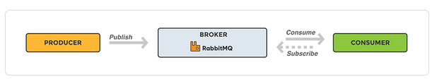

The basic architecture of a message queue is simple - there are client applications called producers that create messages and deliver them to the broker (the message queue). Other applications, called consumers, connect to the queue and subscribe to the messages to be processed. Software may act as a producer, or consumer, or both a consumer and a producer of messages. Messages placed onto the queue are stored until the consumer retrieves them.

